**Streamlit Dashboard**

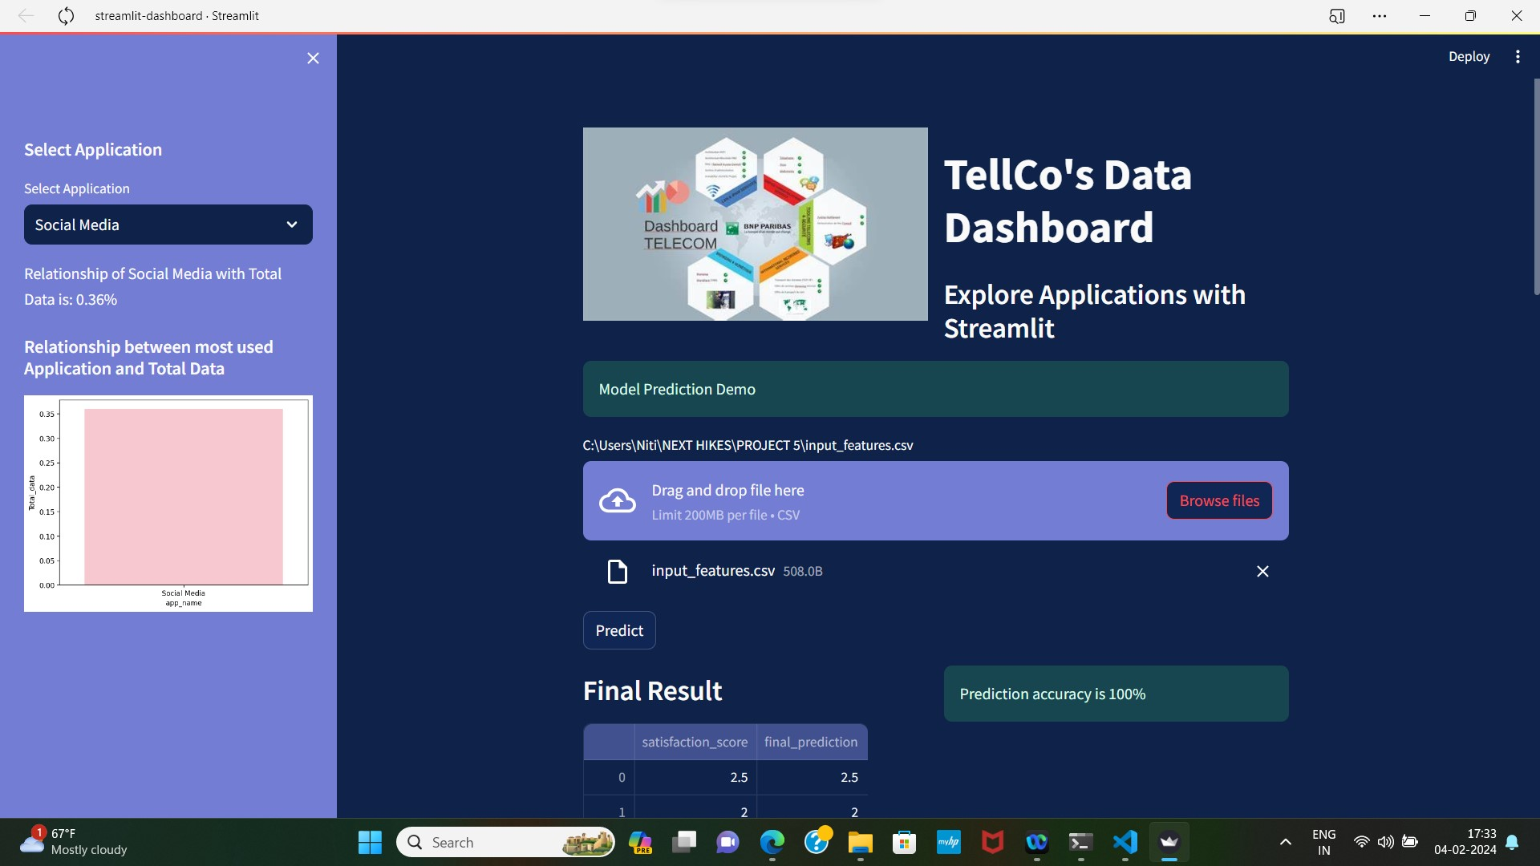

**When we click on BROWSE FILES, and enter input features, a button ‘PREDICT’ comes and on clicking that button we get Final Result of our prediction**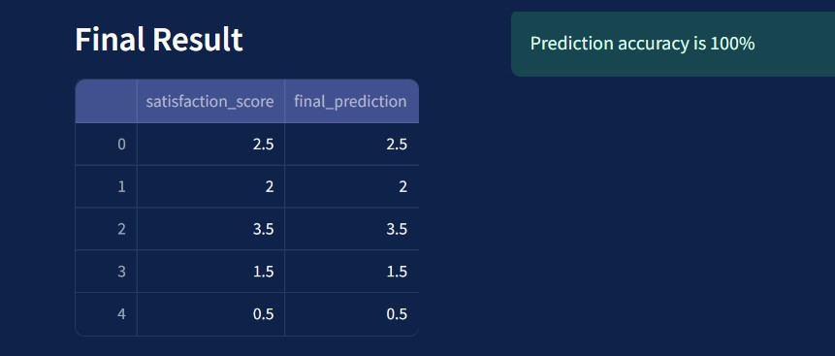

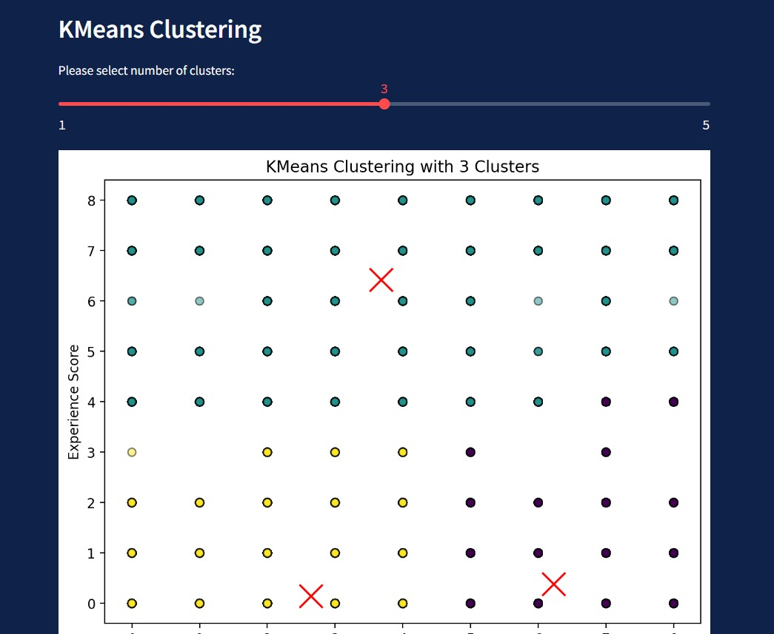

**A slider has been made to select the number of clusters, so that we can give input for the value of k**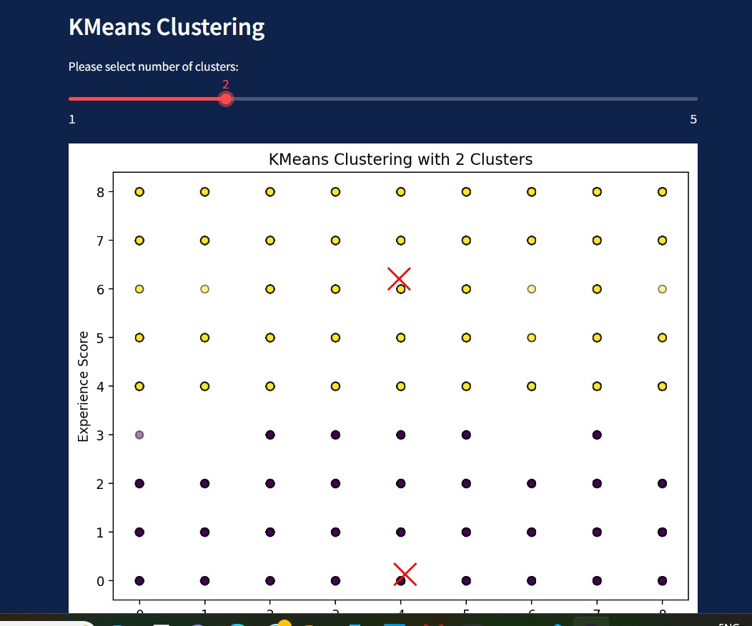

**Following are the sidebars in which we need to select the name of the application and while clicking on a particular application, we get the relationship with Total data in percentage and also a chart of that application**

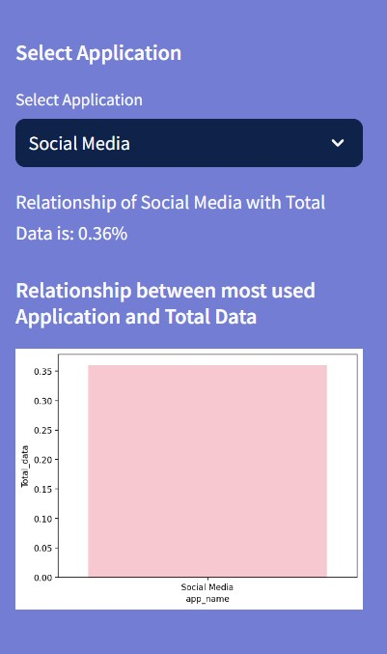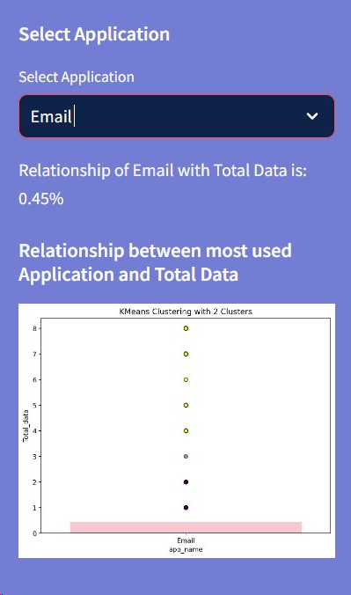

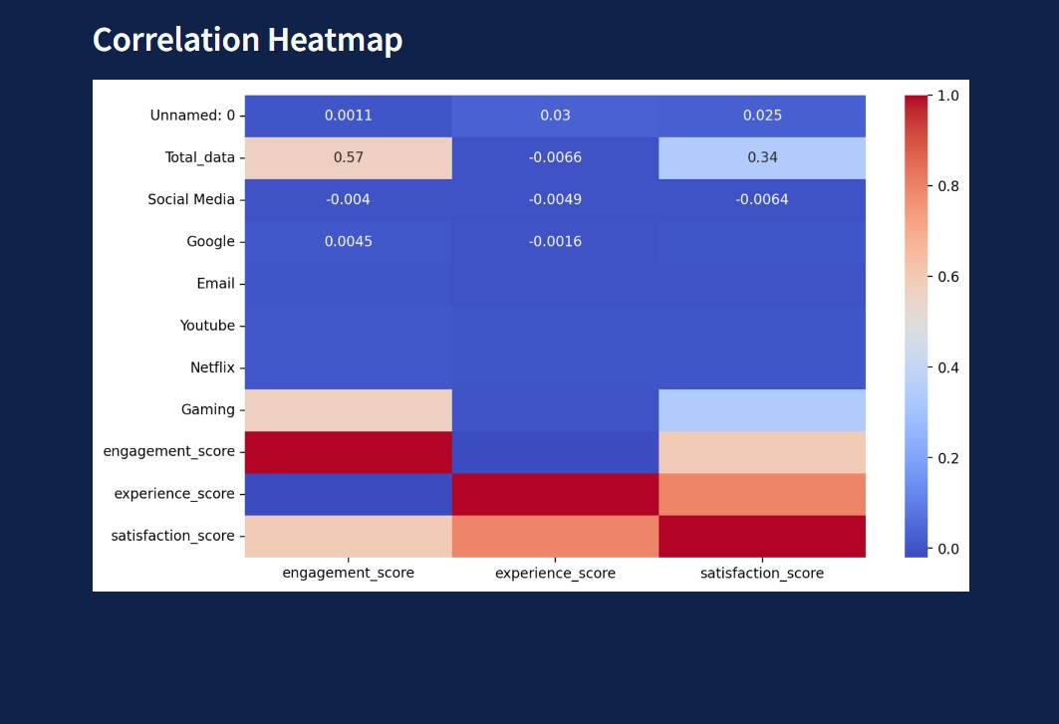

**This is correlation between Engagement score, Experience score and Satisfaction score**

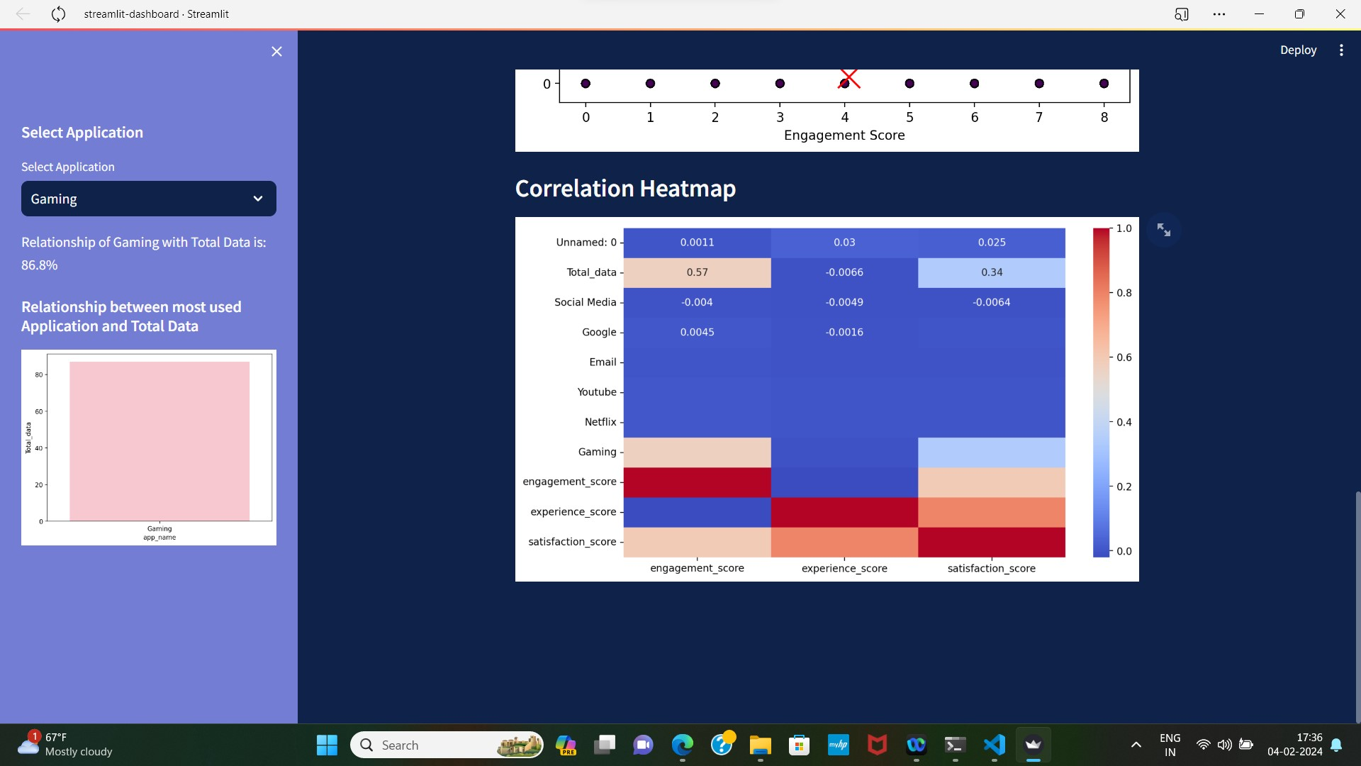

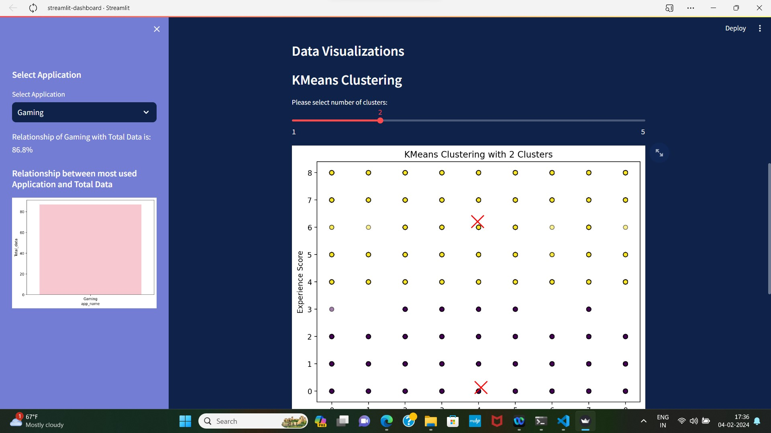

This is my Streamlit dashboard, its running on the localhost but I could not deploy it because while deploying, it created a lot of disturbance in my system due to which many files got corrupted. That’s why I have taken the screenshots of my dashboard and made a word file here to explain how it looks.